Event Manager

1. Save location Object to Location Table

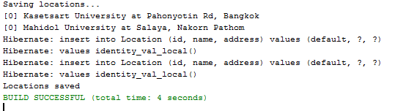

1. Retrieving Location objects from database

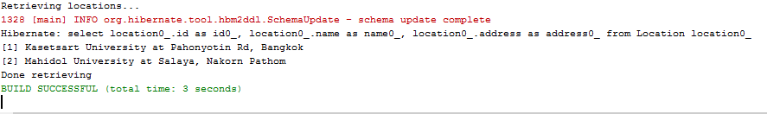

1. Update the location from the existing location using university name



1. Retrieving data after updating

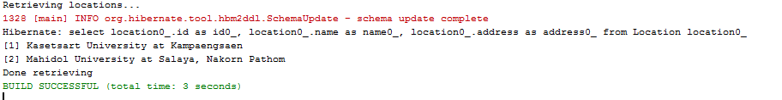

1. Adding event to the database by using many to one mapping of location class



1. Retrieving data after saving the event

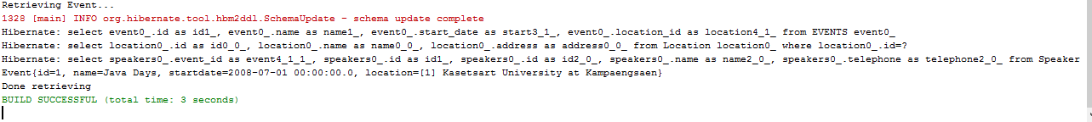

1. Updating location to an event



1. Adding speakers to an event

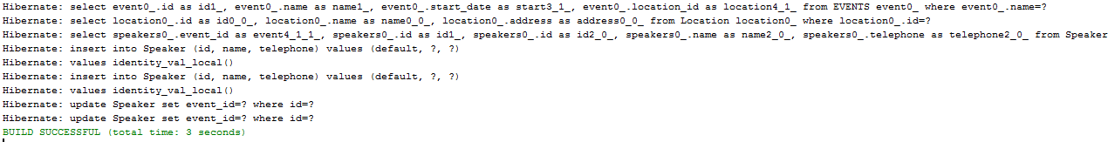

1. Retrieving data after adding speakers

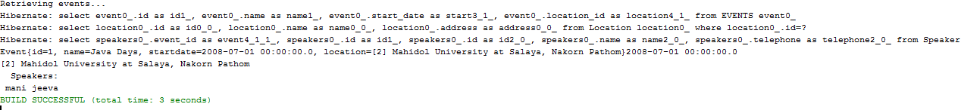

1. Lazy Exception

